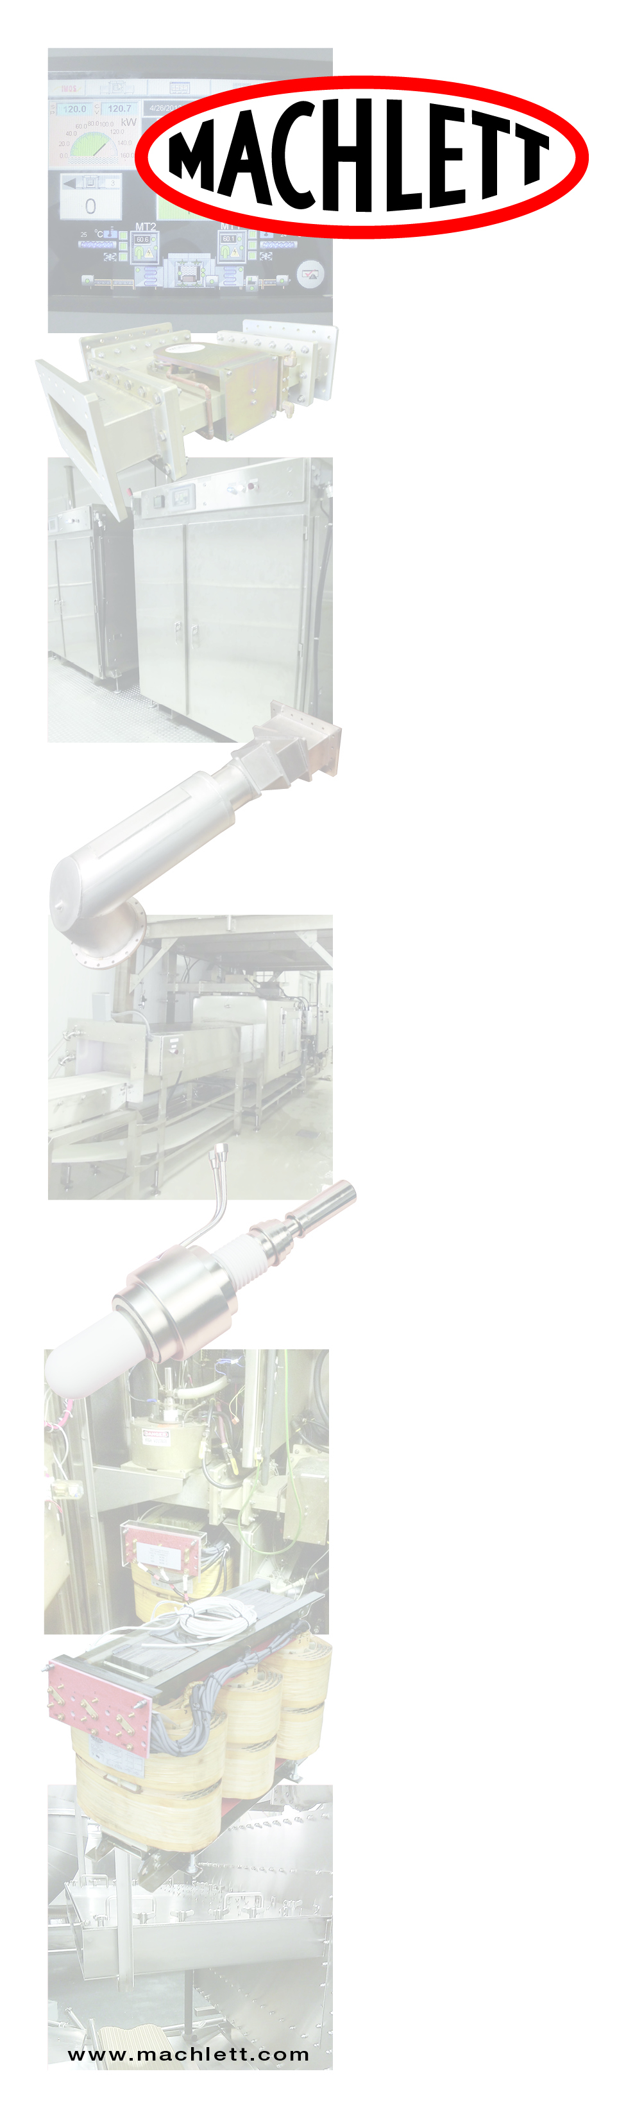

#### Improved Product Quality

* Complete temper regardless of air holes or voids in the product
* Temperature uniformity of finished goods +-1 degree F at 28 degrees F
* Guaranteed temperature stability for a variety of different sized products
* Taste improves due to the retention of protein and natural juices
* Texture of the product improves due to the consistent and uniform temperature profile
* Eliminates the traditional cold center produced from traditional tempering rooms
* Greater control in the degree of temper, power and speed adjustments can be made to tune the process
* Eliminates the effects of over and under tempering
* Improved portion control providing consistent weight and slice thickness

#### Production Savings

* Drip Loss savings of 5%-10%
* Elimination of warm water bath
* Labor savings microwave tempering takes place in the carton, eliminates double handling
* Carton is easily stripped after the tempering process
* Energy savings due to the exact temper uniformity.
* No extra cost of re-freezing due to over tempered product
* Faster processing times. Microwave tempering done in minutes
* Flexibility to processing schedule because microwave tempering is done only as required
* Minimal inventory in process at any time
* Minimal loss of product in the event of a shutdown

#### Cost Savings

* $0.25 / pound less than conventional blast freezers
* $.0033 / pound amortization of microwave tempering of only 1/3 cent /pound
* One year payback with drip loss savings alone
* Elimination of waste water disposal charges
* The cost of building and maintaining a tempering room is eliminated
* 95% floor space savings
* Cost savings due to reduced cleanup time of less than one hour
* Convert existing tempering space to other uses

#### Machwave Technology

* High efficiency microwave energy coupling into the product of greater than 95%.
* This means all the energy produced from the microwave portion is used with little or no energy loss.
* Computer controlled microwave power will maximize rates and balance power uniformity levels in the cavity.
* Product doors provide optimum safety and protection.
* 6 kW up to 300 kW of microwave power at 915 MHz.

#### Processing

* No equilibration time required. Product can be processed directly out of the microwave.
* Versatility - the system allows the processor to switch quickly and adjust production to meet daily needs.
* Specific product profiles can now be dialed in for instant changes during production via computer controls.
* The producer can now slice and grind to make delicate products.

#### Bacteria / Spoilage

* Reduces HACCP an E-Coli concern. Microwave tempering takes place in the box in minutes.
* Bacterial growth reduced due to the short processing time of only a few minutes from freezer to production.
* Eliminates wastewater disposal concerns

#### Low Maintenance

* Maintenance costs compared to tempering rooms have shown the microwave costs to be less than 1/10 of 1%
* Microwave system is virtually maintenance free.
* The cavity system requires a simple rinse after production.

**Penta Labs/Machlett Microwave** 9740 Cozycroft Ave., Chatsworth, CA 91311 Office: 800-421-4219 ext. 205

**Industrial Microwave**

**Systems & Service**

